Institution Details

Province | Sindh | City | Karachi
Institution | National University of Computer and Emerging Sciences (FAST-NU) | Campus | Karachi
Department | Computer Science | Degree Level | BS
Degree Program | Computer Science | Telephone
Fax

Supervisor Details
Name | Saeeda Kanwal | Gender | Female
Mobile | +92 336 8458203 | Office No | NA
Email | Saeeda.Kanwal@nu.edu.pk | Designation
Qualification

Co-Supervisor Details
Name | NA | Gender | NA
Mobile | NA | Office No | NA
Email | NA | Designation | NA
Qualification | NA

Head of Department Details

Name | Dr. Zulfiqar Memon | Mobile No. | -
Email | zulfiqar.memon@nu.edu.pk | Gender | Male

Project Details

Project Title | StudyMateAI
Group Details | Member 1 Name: Fawaz Ahmed  Member 1 Roll#: k21-4717 |  | Member 2 Name: Shahzaib Mirza  Member 2 Roll#: k21-3819 |  | Member 3 Name: Muhammad Daniyal  Member 3 Roll#: k21-4723
Project Area of | LLM(Large Language Model), NLP(Natural Language Processing), web development
Specialization
Project Start | 18th September, 2024 | Project End Date |  | June, 2025 (tentative)
Date
Project | Project Introduction:  StudyMateAI is a cutting-edge, AI-powered student management system developed to significantly enhance the educational experience for teachers, students, and parents alike. By harnessing advanced AI technologies, StudyMateAI offers a suite of core functionalities designed to streamline both learning and teaching processes. One of its standout features is the ability to automatically generate comprehensive quizzes and practice exams from various input documents, such as textbooks and PDFs. This automation saves educators valuable time by eliminating the need for manual quiz creation, allowing them to focus more on engaging with students. For students, it provides customized study materials tailored to their individual progress and learning needs.  Additionally, StudyMateAI goes beyond static text by incorporating AI-driven video summarization capabilities. It distills complex educational videos into key points and essential concepts, making it easier for students to grasp and revise content quickly. By integrating features such as personalized quiz generation, real-time feedback, and progress tracking, StudyMateAI aims to create a more interactive, efficient, and adaptive learning environment. The platform also fosters better parental involvement by providing tools to monitor academic progress, ensuring a comprehensive, collaborative approach to education.
Summary (less
than 2500
characters)
Project | Project Objectives:  - Automate Study Material Generation:  Develop an AI system to automatically generate quizzes, exams, and customized study materials from input documents like PDFs and textbooks. This automation saves educators time and ensures that students receive relevant and structured practice materials tailored to the curriculum.  - Enhance Video Learning:  Implement AI-powered video summarization to extract key concepts from educational videos, helping students revise content more quickly. This feature condenses lengthy videos into concise summaries, making it easier for students to focus on essential points during revision.  - Personalize Learning Experiences:  Use AI to tailor study material recommendations based on individual student progress and performance. By analyzing students' learning patterns, the system provides personalized resources, helping them focus on areas that need improvement.  - Improve Teacher Efficiency:  Automate quiz creation and study material preparation, reducing the time teachers spend on administrative tasks. This allows teachers to dedicate more time to teaching, student engagement, and improving the overall classroom experience.  - Simplify Parent Involvement:  Provide parents with an easy-to-use interface to monitor their child’s academic progress and quiz results. This feature keeps parents informed about their child’s performance, enabling better support and communication between parents, teachers, and students.
Objectives (less
than 2500
characters)
Literature Review / Background Study | Literature Review:  The integration of AI in education has brought about a transformative shift, revolutionizing how students learn and how educators teach by automating traditionally time-consuming tasks such as content and quiz generation. AI technologies like Natural Language Processing (NLP) and machine learning now enable the automatic generation of quizzes and exams from input documents, including PDFs, textbooks, and other educational resources. This not only saves teachers countless hours but also ensures that students receive consistent, high-quality assessments tailored to their specific needs and curriculum.  In addition to quiz generation, AI-based video summarization represents another key advancement in the field of educational technology. By employing sophisticated techniques such as extractive and abstractive summarization, AI condenses lengthy educational videos into concise summaries, extracting key points and essential concepts. This enables students to retain information more effectively while also facilitating quick revisions, especially during exam preparation or when revisiting complex subjects.  Personalized learning systems have become a central component of modern education, as AI models can now adapt study materials to individual student performance. These systems analyze student progress using machine learning algorithms and provide targeted recommendations based on each student's unique strengths and areas for improvement. This level of personalization enhances learning outcomes and boosts overall efficiency, offering students a more tailored and engaging educational experience.  Moreover, AI-powered platforms that involve parents in the learning process further improve educational outcomes. By allowing parents to monitor their child's academic progress in real time, these platforms foster better communication between parents, teachers, and students. This collaboration contributes to improved student performance, as parents become more engaged in supporting their child's educational journey. The seamless integration of AI across these areas marks a significant step forward in making education more adaptive, efficient, and personalized.
Project Implementation Method (less than 2500 characters) | System Architecture and Methodology  The StudyMateAI system is designed as a modular AI-powered platform that automates content generation and personalization for students, teachers, and parents. It is built with a React frontend, Flask backend, and integrates with specialized AI models and APIs for a streamlined educational experience.  Core Modules and System Components:  - Input Processing:  - Uses Natural Language Processing (NLP) algorithms to extract key information from PDF documents and lecture notes. The system leverages pre-trained transformer models (like BERT or GPT) to parse educational materials, identify critical concepts, and clean noisy data for downstream tasks.  - Quiz Generation:  - This module generates quizzes dynamically by analyzing document structures such as headings, paragraphs, and bullet points. Using Question-Answer Generation models, it produces contextually relevant questions. This ensures that each quiz is customized based on the complexity and importance of the material extracted.  - Video Summarization:  - Powered by pre-trained deep learning models for video analysis and text summarization, this module extracts key points from video lectures. Speech-to-Text APIs convert spoken words into text, and summarization models condense this data into concise summaries. This allows students to grasp the core message of long videos quickly.  - Personalization Engine:  - A machine learning-based recommendation system monitors each student’s learning behavior and quiz performance. The engine adapts to their learning progress, offering tailored study suggestions. This component integrates with a custom-built recommender model trained on user performance data to ensure that recommendations evolve as students' abilities grow.  - Parental Dashboard:  - A separate interface for parents built using React. It fetches real-time data from the backend on students’ performance, providing intuitive visualizations (such as graphs and progress trackers). The dashboard focuses on giving insights into academic areas where the child excels or needs improvement.  Methodology:  - Requirement Analysis:  - Conducted interviews with target users (teachers, students, parents) to map out core needs. Special attention was paid to scalability and user experience for each module. The system architecture was designed with modularity in mind to facilitate independent upgrades of individual components.  - Data Collection:  - Built a customized data pipeline to gather diverse educational resources. This included scraping public educational datasets, and collecting user performance data. The system anonymizes all data to ensure compliance with privacy standards.  - Model Training and Fine-tuning:  - Pre-trained NLP models will be fine-tuned on domain-specific educational data. This included tuning models for question-answering tasks, text summarization, and video speech analysis.  - System Integration:  - Developed a RESTful API layer using Flask for handling communication between the frontend and backend. The backend manages requests related to quiz generation, video summarization, and recommendation engines. Extensive use of microservices architecture ensures that different modules can scale independently as system usage grows.  - Testing and Validation:  - Multiple rounds of user testing will be conducted with both students and teachers. The quiz generation algorithm will be validated for accuracy and relevance, while video summaries will be assessed for completeness. The personalization engine will be rigorously tested for its ability to recommend relevant content based on actual user performance.  - Deployment and Continuous Improvement:  - The system is deployed on a cloud platform like AWS, ensuring high availability and scalability. Continuous integration/continuous deployment (CI/CD) pipelines were set up to streamline updates based on user feedback. Ongoing improvements focus on enhancing model accuracy and user satisfaction, as monitored through real-time analytics.
Benefits of the | The StudyMateAI platform offers several groundbreaking benefits that address limitations in existing educational tools, providing enhanced functionality and a more accessible experience.  1. Free and Accessible  Unlike most existing tools that are behind paywalls for the use of their full feature [1] [2], StudyMateAI is completely free to use, making high-quality educational resources accessible to all students and teachers regardless of financial constraints.  2. Expanded PDF Upload Capacity  Existing products restrict the number of pages or characters users can upload (typically 50-100 pages or a few thousand characters) [1]. StudyMateAI removes these limits, allowing users to upload larger documents without compromising on content, ensuring that all learning materials can be processed in one go.  3. Answer Validation and Explanations  StudyMateAI offers answer validation, providing detailed explanations for incorrect answers. This feature is rarely available in existing tools and plays a crucial role in improving student comprehension by not just marking answers wrong but explaining why.  4. Targeted Quiz Generation  Most platforms generate quizzes based on entire documents, which can be overwhelming and inefficient. StudyMateAI introduces the ability to create quizzes from specific sections, page ranges, or topics, allowing for more focused and effective learning based on particular study areas.  5. Customizable Timed Quizzes  Unlike current systems, which lack time-management features, StudyMateAI allows users to set a custom timer for quiz attempts. This feature promotes effective time management, helping students practice completing tasks within a set timeframe—an essential skill for exams and real-world challenges.  6. Personalization and Flexibility  StudyMateAI’s core AI-driven functionality enables personalized quiz generation, tailored explanations, and flexible learning options, setting it apart from rigid, one-size-fits-all solutions. The platform adapts to individual learning needs, enhancing the overall educational experience.  Conclusion  By addressing the limitations in existing products, StudyMateAI revolutionizes the educational landscape with a free, accessible, and highly functional platform. Its unique features expanded upload capacity, targeted quiz generation, answer validation, and time management support ensure a more personalized, efficient, and effective learning experience.
Project (less
than 2500 characters)

Technical | The final deliverable for StudyMateAI is an AI-powered educational platform designed to automate and personalize learning. Here are the technical details:  - System Architecture  - Backend: Built with Python-based frameworks (e.g., Flask or Django) to handle data processing, model integration, and user management.  - Frontend: Developed using HTML, CSS, and JavaScript for a responsive and user-friendly interface.  - Database: A relational database (MySQL) stores user data, performance metrics, and content.  - Core AI Modules  - Quiz Generation: Pre-trained language models (Lama or BERT) generate quizzes from input documents such as PDFs and textbooks.  - Video Summarization: Speech-to-text combined with extractive or abstractive summarization techniques generates concise transcripts of educational videos.  - Personalization Engine: Machine learning models analyze student performance data to recommend study materials, tailoring quizzes and resources based on progress.  - APIs and Integrations  - Document Processing API: Extracts content from documents and feeds it to the NLP model for quiz generation.  - Video Processing API: Converts video speech to text for summarization.  - User Interfaces  - Teacher Dashboard: Allows educators to upload documents/videos for quiz generation and video summarization, with the ability to modify content before sharing.  - Student Interface: Displays personalized quizzes, video summaries, and progress reports, offering real-time feedback and recommendations.  - Parent Dashboard: Enables parents to monitor student performance, quiz results, and academic engagement.  - Security and Data Privacy  - User Authentication: Uses JQuery or JWT tokens for secure login and data protection.  - Data Encryption: Ensures sensitive data (e.g. student progress) is encrypted in transit and at rest.  - Performance Monitoring  - Analytics Dashboard: Provides real-time monitoring of system performance, user engagement, and content effectiveness.  - Logging and Alerts: Tracks errors and performance metrics for quick issue resolution.  - Final Deliverable Summary  - The deliverable is an AI-powered platform offering NLP/LLM-based quiz generation, video summarization, and personalization features. It includes dashboards for teachers, students, and parents, ensuring an efficient, engaging, and secure educational experience.
Details of Final Deliverable (less than 2500 characters)
Final Deliverable of the Project | Final Deliverables:  The final deliverable for StudyMateAI is a comprehensive AI-powered educational platform designed to automate the creation of personalized study materials, including quizzes, and improve the learning experience for students, teachers, and parents. The platform integrates cutting-edge AI technologies to deliver key features that address gaps in existing educational tools.  Key Features:  - Free Access:  - The platform will be entirely free, removing financial barriers for educators and students.  - Unlimited PDF Uploads:  - Users can upload larger PDFs, surpassing the page and character limits found in other systems.  - Targeted Quiz Generation:  - Quizzes can be generated based on specific sections, page ranges, or topics from documents, rather than from the entire document.  - Answer Validation and Explanations:  - The platform will validate answers and provide explanations for incorrect responses to improve student comprehension.  - Customizable Timed Quizzes:  - Users will be able to set a timer for quizzes, helping students practice time management skills.  - User Dashboards:  - Teachers: Add student’s numbers and attendance, and view student progress.  - Students: Upload PDFs, generate quizzes, access study materials and personalized progress reports.  - Parents: Monitor student progress and engagement.  The final deliverable is a feature-rich, AI-driven platform that supports personalized and efficient learning experiences while promoting better engagement and understanding for all users.
Core Industry (Optional)
Other
Industries
(Optional)
Core | NodeJS, ReactJS, Python, Mysql, Flask
Technology
Other | Figma
Technologies
(Optional)
Sustainable
Development
Goals
(Optional)
References

Project Key Milestones
Elapsed time in (days or weeks or month or quarter) since start of the project |  | Milestone | Deliverable
Month 1 |  | Define Proposal, Requirements, and  Defense | Defense of project idea, detailed proposal document with core requirements
Month 2
  Design & Prototyping
  System architecture, user flow
  diagrams, screen designs, and
  basic prototypes
Month 3
  Backend Services & Database Setup
  Database schemas, API design, cloud setup, and basic logic for quiz generation
Month 4
  Frontend Development & Backend Integration
  Frontend interface (for students, teachers, parents), UI/UX improvements, and backend integration
Month 5
  AI Integration & Feature Development
  Integration of AI-driven quiz generation, video summarization, and personalization engine
Month 6
  Complete Feature Development
  Refinement of all features (quiz generation, progress tracking, parent monitoring)
Month 7
  Testing & Feedback
  Unit testing, performance testing, security checks, final feedback from stakeholders
Month 8 |  |  | Final project report, technical documentation, and project submission for evaluation
  Final Report & Project Evaluation

Gantt Chart

Critical tasks highlighted

System Diagram
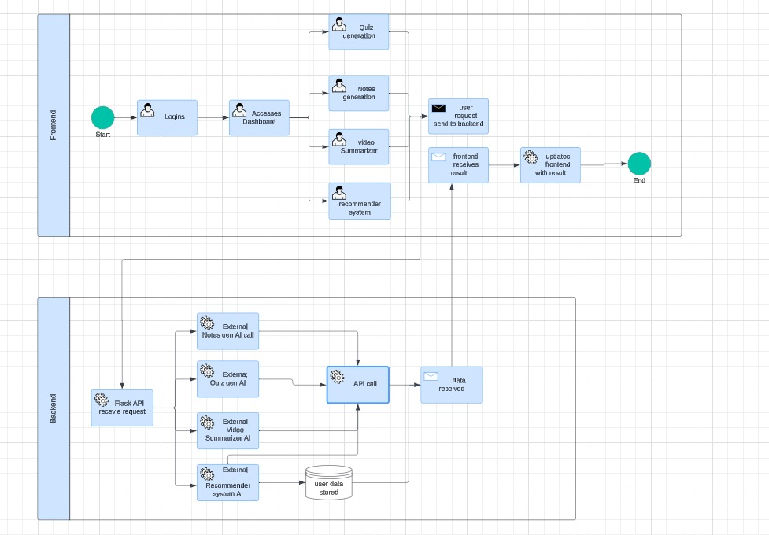
Project Equipment Details

Item(s) Name | Type | No. of Units | Per Unit Cost (in Rs) | Total (in Rs)
 |  |  | Total in (Rs)

